<http://beginnersbook.com/java-tutorial-for-beginners-with-examples/>

http://beginnersbook.com/2013/04/java-exception-handling/

Pg 347 – 355 Java Programming *A comprehensive Introduction*

**Section 1: Define**

Describe the difference between an **Error** in Java and an **Exception.**

**Errors should not be caught or handled (except in the rarest of cases). Exceptions are the bread and butter of exception handling.**

Describe the difference between **Checked Exceptions** and **Unchecked Exceptions**

Checked: are the exceptions that are checked at compile time. If some code within a method throws a checked exception, then the method must either handle the exception or it must specify the exception using throws keyword.

Unchecked are the exceptions that are not checked at compiled time.

Give a few examples of **Checked Exceptions.**

|  |
| --- |
| class Main {      public static void main(String[] args) {          FileReader file = new FileReader("C:\\test\\a.txt");          BufferedReader fileInput = new BufferedReader(file);            // Print first 3 lines of file "C:\test\a.txt"          for (int counter = 0; counter < 3; counter++)              System.out.println(fileInput.readLine());            fileInput.close();      }  } |

Output:

Exception in thread "main" java.lang.RuntimeException: Uncompilable source code -

unreported exception java.io.FileNotFoundException; must be caught or declared to be

thrown

at Main.main(Main.java:5)

Give a few examples of **Unchecked Exceptions.**

|  |
| --- |
| class Main {     public static void main(String args[]) {        int x = 0;        int y = 10;        int z = y/x;    }  } |

Output:

Exception in thread "main" java.lang.ArithmeticException: / by zero

at Main.main(Main.java:5)

Java Result: 1

Describe basic structure of

**try**{

}

**Catch**

{

}

A try statement is used to catch exceptions that might be thrown as your program executes. You should use a try statement whenever you use a statement that might throw an exception That way, your program won’t crash if the exception occurs.

**Programming Tasks:**

Task 1- Create coded examples of ArithmeticException, ArrayIndexOutOfBoundsException, and NegativeArraySizeException Handling. Do not use the exact example from the book. Create your own.

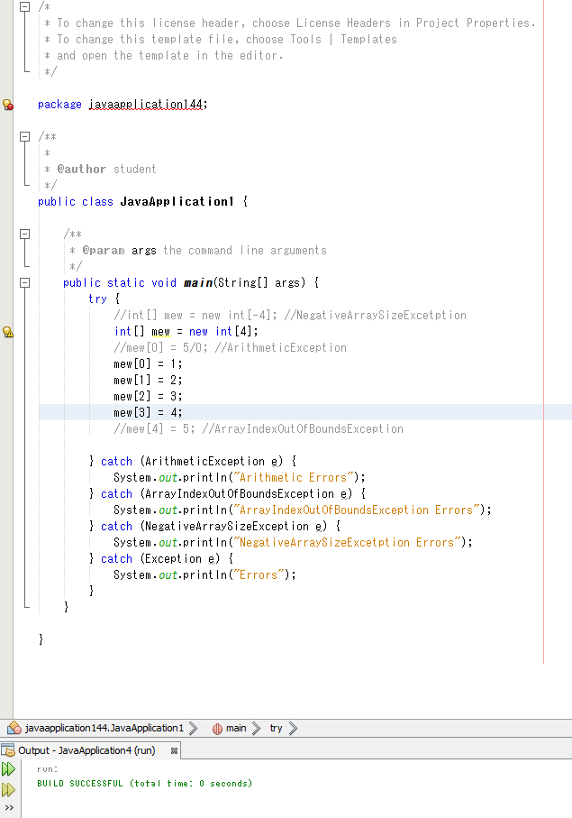

Task 2- Incorporate exception handling into anyone of the previous programming tasks have completed. Make it clear the change in code.

